In BarPlot.html and PieChart.html, Plotly JS is used to draw the bar graphs and Pie Charts as well. To include Plotly JS in webpage, include the below line in head tag of the webpage

**<script src =”https://cdn.plot.ly/plotly-latest.min.js”></script>**

|  |
| --- |
|  |
|  |
|  |

Let us understand the process of drawing Bar Charts:

**Bar Graphs:**

Consider the below script:

var data = [

{

x : [‘city-1’,’city2’,’city3’],

y : [20,40,60],

type : bar

}

];

Plotly.newPlot(‘MyDiv’,data)

This above scripts plots a bar graph with **x** values as headings and **y** values as height of the bar in the **data** variable. **type** is used to the indicate the plot. Here as we are plotting bar graph, it is **bar.** The Plotly.newPlot function takes two arguments. First argument is element in the webpage where plot is displayed and second argument is the data itself. For sample Bar graph, refer HTML file [here](https://github.com/MANIDEEP007/SSPART/blob/master/BarPlot.html). The sample Bar Graph looks like below: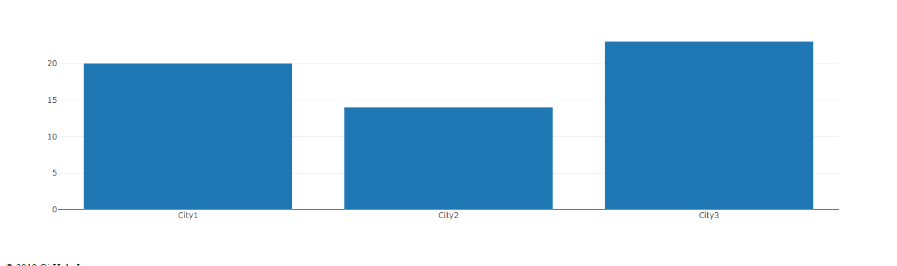

**PIE CHARTS:**

Consider the below script:

var data = [

{

labels : [‘Comedy’,’Fiction’,’Horror’],

values : [20,40,60],

type : ‘pie’

}

];

Plotly.newPlot(‘MyDiv’,data)

This above scripts plots a Pie chart with categories as values of **labels** in the **data** variable as headings and y values as percentage of the circle. **type** is used to the indicate the plot. Here as we are plotting Pie Chart, it is **pie.** The Plotly.newPlot function takes two arguments. First argument is element in the webpage where plot is displayed and second argument is the data itself. For sample Pie Chart, refer HTML file [here](https://github.com/MANIDEEP007/SSPART/blob/master/PieChart.html). The sample PieChart looks like below:

